Project Design Phase-II Technology Stack (Architecture & Stack)

Date | 01 February 2026
Team ID | LTVIP2026TMIDS24102
Project Name | Heritage treasures: an in-depth analysis of UNESCO world heritage sites
Maximum Marks | 3 Marks

Table-1 : Components & Technologies:
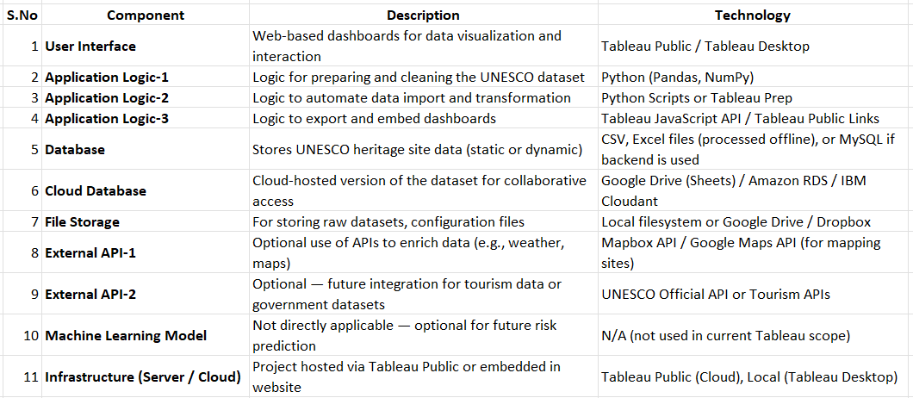

Table-2: Application Characteristics:
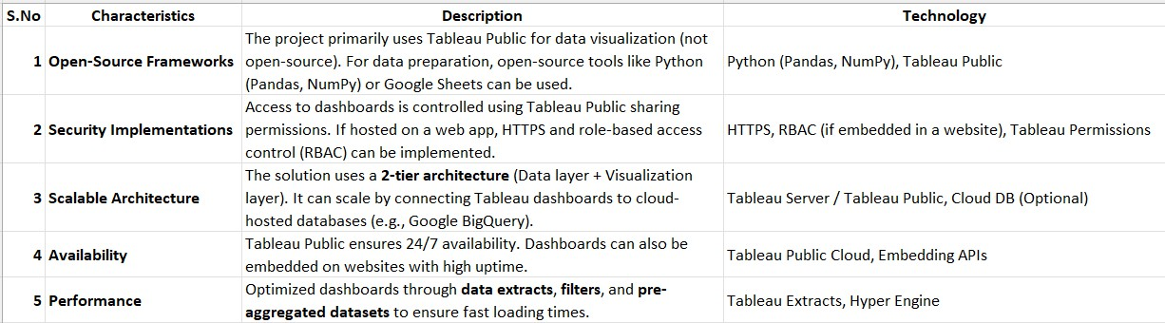
References:
https://whc.unesco.org/en/list/ https://whc.unesco.org/en/dive-into-heritage/ https://whc.unesco.org/en/danger/
https://en.wikipedia.org/wiki/World_Heritage_Sites_by_country
https://old.datahub.io/dataset/unesco-world-heritage-sites/resource/d4116195-44d8-4bc1-9f91-9b570870dc19 https://www.tableau.com/visualization/data-visualization-examples https://www.google.com/search?q=https://public.tableau.com/en-us/gallery/
https://www.tableau.com/dashboard/dashboard-examples

